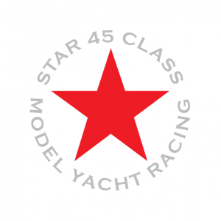
Sailing Instructions
Star 45 Region 2 Championship Regatta
September 12-13, 2022
Organized by Chesapeake Bay Model Racing Association—AMYA #11

Rules: The regatta will be governed by The Racing Rules of Sailing 2020-2024, as amended by Appendix E for RC sailing, prescriptions of US Sailing, and further Sailing Instructions as announced by the Race Director during the course of event.
- We are here to enjoy ourselves. Please keep this in perspective. We are a group of grown adults playing with toy sailboats.
- Penalty turns will be 360’s immediately following infraction. Don’t whine about it; just do it!
- Protests not settled on the water will be taken to committee. With that in mind, please also refer to instruction #1
- A two (2) minute tape is used for starts. There may be a one-minute warning prior to the tape starting
- One Five-minute Hold per skipper per day, unless a burdened vessel damaged your boat
- Refer to instruction #1 one last time. Good luck and have fun.

Racing Format More than 20 entries may prompt a CESS pool or HMS format at Race directors discretion, otherwise all boats will start together. Course will be set based on the prevailing conditions and announced prior to the start of each race.
Scoring: The event will be scored under the Low Point Scoring System as described in the Racing Rules of Sailing Appendix A. For each 8 races sailed, a boat’s worst score, excluding penalty points, will be deducted.
Schedule of Events:
Monday, September 12, 2022
Registration/Setup ~ 8:30 – 9:15 am
Skippers Meeting ~ 9:15 am
Racing begins following meeting
Lunch break ~ 12:30 pm
Racing ~ 1:15 pm to 4:00 pm
Tuesday, September 13, 2023
Skippers Meeting ~ 9:15 am
Racing begins following meeting
Lunch break ~ 12:30 pm
Racing ~ 1:15 pm to 3:30 pm

Awards: Awards to Three to five places depending on the number of entries will be presented after the scores are tabulated
Contact: Scott Graf, scottgraf@yahoo.com 443-510-5455 (M)

